Editable Related List - Configuration

Which fields to display within this Editable Related List component is defined from Custom Metadata. In here, we define the Child Object we are looking at, the Parent Object and the fields we want to display in our Related List. We then simply, drag the Lightning Component onto the Parent Object’s Lightning Page Layout, and insert the Child Object API Name.

# Custom Metadata

You can find this within Setup > Custom MetaData Types > ‘ERL Data’.

In this scenario, we are going to create a Contacts Editable Related List, which will be displayed on Account Record Pages.

## The Parent – Child ERL Meta record

1. Within **ERL Data**, select ‘Manage ERL Data’
2. Select ‘New’
3. Enter a **Label** and define the **Order** (position of the field in the Related List)
4. Select whether you would like this field to be **Visible** and **Editable** using the corresponding checkboxes
5. **Parent Object** – in this instance, set this to ‘Account’
   1. **Parent Object** is only required when defining the field which is the Lookup field to the Parent Object. For example, ‘Account’ is the Parent Lookup field for Contacts. This needs to be included in at least one of the ERL Meta Data records, so that the Parent-Child relationship is defined.
6. **Child Object** – set this to ‘Contact’
   1. **Child Object** defines the type of records which are going to be shown in the Related List
7. **Child field** – set this one to ‘Account ID’, as this is the field that connects Contacts to Accounts.
8. **Save**

## The Child ERL Meta record

1. Within **ERL Data**, select ‘Manage ERL Data’
2. Select ‘New’
3. Enter a **Label** and define the **Order** (position of the field in the Related List)
4. Select whether you would like this field to be **Visible** and **Editable** using the corresponding checkboxes
5. **Parent Object** – in this instance, leave this blank
6. **Child Object** – set this to ‘Contact’
7. **Child field** – select a field you’d like to display in your Related List
8. **Save**
9. **REPEAT** for all desired fields

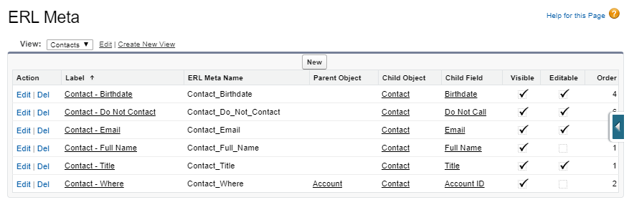

# Lightning Page Setup

Once you have the fields setup in the **ERL Meta** Custom MetaData Object, you can then proceed to add the Lightning Component to the **Account’s** Lightning Page.

Open the Account Lightning Page Builder, by one of the two following options:

1. Setup > Object Manager > Account > Lightning Record Pages > ‘Account Record Page’
2. Navigate to a Account Record > Settings Cog > Edit Page

Once in the Lightning Page Builder, we can then proceed to configure our Editable Related List:

1. Drag the ‘EditableRelatedList’ component from the left-hand **Components** ‘Custom’ section, onto the page in a desired location. In this case, you should be on the Lightning Page Builder for Accounts.
2. **Child Object Label** – enter the ‘Label’ for the Child Object. In this case, we are inserting a Editable Related List for Contacts, on the Account page. Enter ‘Contact’ into this box.
   1. If we were configuring this for a Custom Object with an API Name of ‘Events__c’, we would enter ‘Events’.
3. **List Title** – Enter ‘Editable Related Contact List’ or a Related List Title of your choosing
4. **List Icon** – Select an appropriate icon for your Related List from this list
5. **List Height** – Set a predefined height for the Related List. If not set, this defaults to 250 px (pixels), to prevent the Related List extending too far if there are a lot of records
6. **Display New Button** – Toggles the ‘New’ button in the top-right of the Related List. This created a new Child record.
7. **Save**

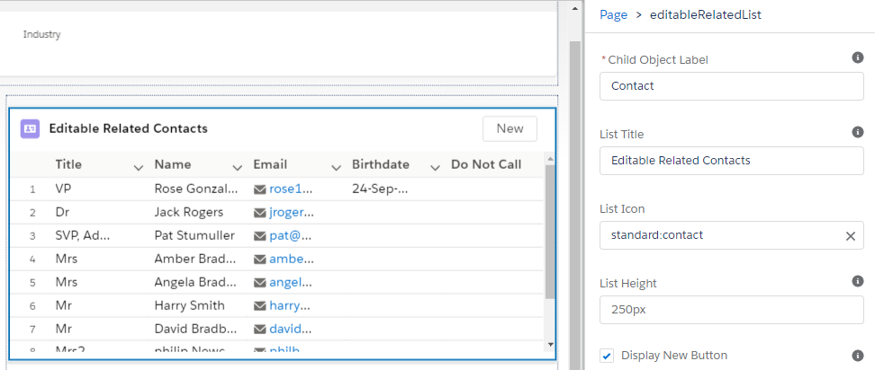

# Permissions

Assign the ERL Permissions Set ‘ERL Meta Access’ to all users needing access to the Editable Related List component.

1. Setup > Permission Sets > ‘ERL Meta Access’ > Manage Assignments
2. Select ‘Add Assignments’
3. Select all Users
4. Hit ‘Assign’